“Dylan’s Bar Mitzvah brought us into the Jewish tribe.” Celebrating outside the Orthodox establishment

Every child longs to feel that they belong, but not every child is welcome in their neighborhood synagogue. Children whose Jewish status is not recognized by the Rabbinate are one example. The Reform movement has decided to embrace these children: “It’s like Abraham’s tent. The inclusive welcome of interfaith families led my family and me personally into the heart of the Jewish tribe,” Michael Douglas told Ynet.

Tali Farkash, 19 July 2017

“It’s like Abraham’s tent. The inclusive welcome of interfaith families in the community encourages acceptance and participation. This was definitely the reason why my family and I found ourselves in the heart of the Jewish tribe.” These comments were made by Michael Douglas, the actor and winner of two Oscars, who told Ynet how a decision by a 12-year-old boy changed their whole family. But the path they took forced them to think outside the box.

Who doesn’t want to have a Bar Mitzva? Any 13-year-old boy who sees his friends showered with candy and standing excitedly by the Torah scroll wants to have the same experience, to feel that they belong. But not everyone is welcome in their neighborhood synagogue. Examples include children whose mother is not Jewish, or whose conversion is not recognized by the Rabbinate.

Michael, the son of the actor Kirk Douglas, was born to a Jewish father and Christian mother. “As a young child, I grew up without any religious trappings,” he explains, although he emphasizes that his home was deeply Zionist. He married the actress and fellow Oscar winner Catherine Zeta Jones, a Catholic, and the couple had two children.

Four years ago, when he reached the age of twelve, Michael’s son Dylan became friends with some Jewish children from his school. “He went to their homes on the Sabbath, saw them lighting the candles, stayed over with them for weekend, and in the morning went to Hebrew school with them. He liked it,” recalled Michael.

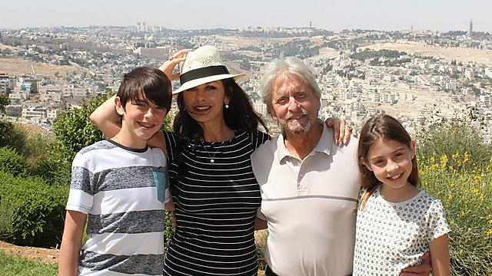
“He brought the basic principles and values of Judaism into our home. And that’s how our family began its journey.” Douglas with Catherine Zeta Jones and their children, in Jerusalem (photo: Gabriel Smith and Yechiel Salomon).

“A few months later, he told us that he wanted to have a Bar Mitzva. Catherine and I thought that he was just interested in the presents and parties. But Dylan amazed us when he started to explain how the burning Sabbath candles lit up his soul.”

Douglas and his wife decided to agree to their son’s request and arrange a Bar Mitzva for him. “He studied very hard,” Douglas Sr. explained two years ago at a panel discussion of the Reform movement. “He brought the basic principles and values of Judaism into our home. And that’s how our family began its journey.”

Douglas told Ynet that this was also his first exposure to the Reform movement: “I’m so grateful to Rabbi David Greenberg of Sha’arei Tefila, our local synagogue, for opening his door to Dylan and our family.” He added: “This is the first time that I was proud to say ‘I’m proud to be Jewish.’”

There I was a Jew, Here I’m a Ukrainian
One of the main fronts of the clash between the Law of Return and Jewish life in Israel comes around Bar Mitzva time. Many boys are left out of this meaningful experience because they are not Jewish according to the Halacha. This might be because they come from an interfaith family, or because they underwent a non-Orthodox conversion. Rabbi Meir Azari, head of the Reform congregation Beit Daniel, is not surprised to hear how difficult it was to find families who are willing to talk about their Bar Mitzva experiences.

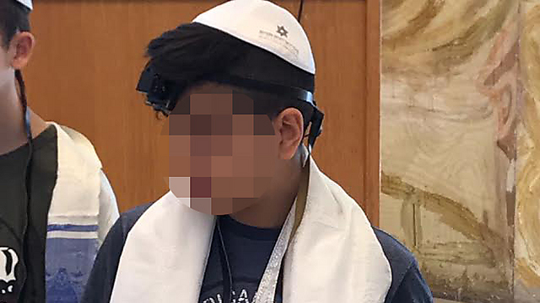
“Before the boy put on Tefillin for the first time, he was really excited and talked about it the whole week.”

Douglas spoke of a large Jewish congregation where interfaith marriage is a social norm, and praised the feeling of a “Jewish home.” In Israel, however, this subject is considered a taboo. “There is a serious stigma against people who marry non-Jews, even though all our Bible heroes married non-Jewish women. In the United States people blame Reform for assimilation. But in France Reform is much weaker, and the assimilation figures are still high. The reality is that in the modern age, people fall in love and marry, and conversion is not always possible.”

Rita Avni came to Israel from Ukraine at the age of 16. Her father was Jewish and her mother was nominally Christian, although in reality she had no religion. “Religion was something that people didn’t talk about – a remnant of the Communist era. Because of my father’s surname, I was considered Jewish, because in Ukraine religious affiliation goes by the father. I suffered a lot from anti-Semitism, only to arrive here and discover that while there I was a Jew, here I’m an outsider. I don’t really belong in either place.”

Avni, who arrived in Israel during the middle of the Gulf War, was unable to undergo an Orthodox conversion. “For my parents, and particularly my Jewish father, it was difficult. They demanded that he do things like undergo circumcision at the age of 53, because his own circumcision wasn’t considered technically kosher. Eventually they kept presenting more demands and there was no end to it. I despaired of the whole process. At the age of 24, when I got married the first time, I wanted to get converted again so that I could marry like everyone else and feel that I belong. Once again I studied for six months, threw myself into it emotionally and physically, but again nothing came of it.”

After her second marriage, to an American-Jewish partner, Avni was exposed to Reform Judaism. “I began the process again. To tell the truth I was pretty scared, but they made me feel part of it all. Not like a second-class Jew. I learned to see Judaism in a different way, more accepting. As far as I’m concerned there’s no difference: my identity card also states that I am Jewish.”

Avni’s son from her first marriage was due to celebrate his Bar Mitzva this coming fall. “I asked him whether he wanted to go up to the Torah or celebrate in some other way. He told me that it’s very important to him. Now we’re in the middle of all the preparations. Before the boy put on Tefillin for the first time, he was really excited and talked about it the whole week. I’m really happy for him, because it’s important for him – and for me, too.

“I want him to complete the whole process – study and read from the Torah. Because of my own unpleasant experiences, I’m trying to prepare for a life that won’t be simple. I tell him that some people will tell him that he isn’t Jewish and that I’m not, either. But he should know that he is.”

From the Philippines to a Bar Mitzva

Avni is not alone. The story of Ephraim and Ludy Kalfi is a typical Israeli story that creates some real headaches for the Interior Ministry and all those involved. We begin our conversation by reliving the couple’s obstacle course in government ministries and courts in order to secure citizenship. An equally difficult experience was the complex struggle to raise Ludy’s daughter (Ludy’s husband died when she was young) here in Israel.

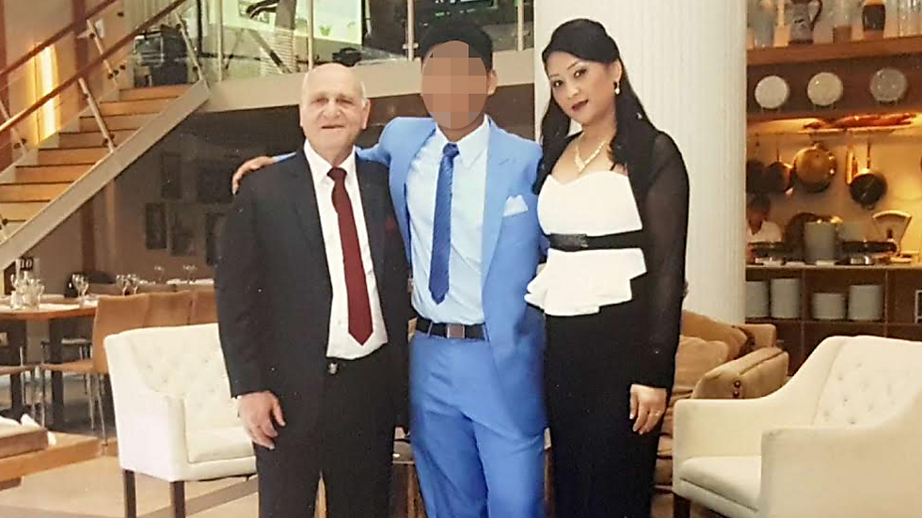
“Judaism is part of our lives. I’d never even stepped foot in a synagogue, but now I go regularly on the festivals and I attend lessons.”

Kalfi fell in love with Ludy while she was working as a caregiver for his mother. “She had worked as a nurse in the Philippines, and here she was a foreign worker,” he recalls. When his mother died, the Interior Ministry demanded that Ludy leave Israel. “They claimed that our relationship was fictitious and just a matter of personal interests. Our child – Ludy’s son – has called me Dad since he was six. But the real change came when he reached the age of 12. We visited him in the Philippines after we managed to sort out Ludy’s Israeli citizenship. He just broke down crying, and begging his Mom not to leave him. I also broke down and cried. I promised him that I’d do everything possible to bring him here. It was a long and hard struggle – but he’s here now.”

After they got married seven years ago, Ludy chose to undergo a Reform conversion. “But it wasn’t just Ludy who converted – I did, too. I’d never even stepped foot in a synagogue. I didn’t know anything about Judaism. I was a lieutenant colonel in the military and that world didn’t interest me. But because I went along to all the classes with my wife, as part of her conversion, I learned about Judaism.

“For our son, it’s something almost automatic. As soon as he landed here I took him to the rabbi at Beit Daniel to get to know them and hear about Judaism. Even then he immediately wanted to convert. We agreed that he would study in the meantime, and we’d set a date for his Bar Mitzva. He didn’t know Hebrew. Every day he studied Hebrew for six hours, and then Jewish studies and reading from the Torah.”

Kalfi says that he was “simply amazed. After one year, a boy who hadn’t known any Hebrew read from the Torah using the traditional trope. He read his Haftarah. And everything was so accurate. It was moving when he was called up to the Torah, and we had a wonderful party with the whole family. I remember standing next to him to hold him, and my eyes were blurry with tears. I couldn’t stop crying – I was so moved.

“He may not be my biological son, but he’s my son. I’m the only father he knows. Everything I do is for him. Two years have passed since then, and he’s a totally Israeli boy now. He’s already got his first draft notice from the military, and I’m doing my best to prepare him for it. We talk a lot about that. Judaism is part of our lives. I’d never even stepped foot in a synagogue, but now I go regularly on the festivals and I attend lessons.”

The Problem is that People Don’t Talk about the Subject
Rabbi Azari quotes the official statistic: 300,000 immigrants from the Former Soviet Union are not recognized as Jews. “And that’s just the beginning. What about someone who goes off to work for Microsoft in the United States and returns with a non-Jewish wife and children? It’s not a rare occurrence – we’re talking about tens of thousands of homes in Israel. No-one writes about it. No wants to talk about it. I want people to know that there’s another option,” he declares.

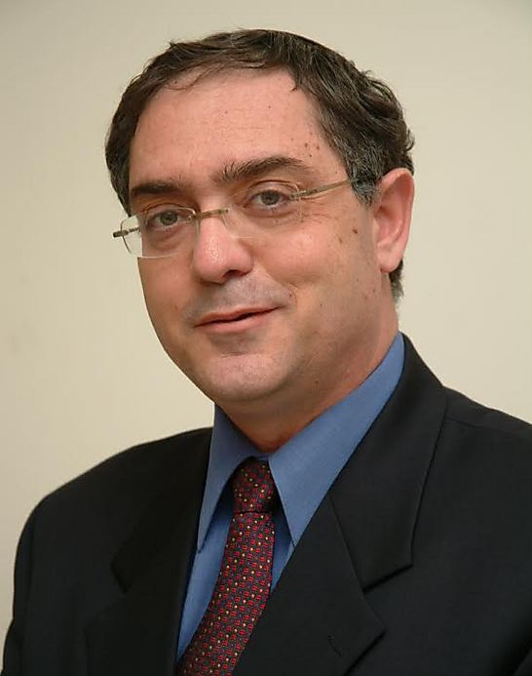

It’s not a rare occurrence – we’re talking about tens of thousands of homes in Israel. Rabbi Meir Azari (photo: Rina Halon)

Why the Emphasis on the Bar Mitzva?
“The goal is to give the parents and the child their first taste of Judaism. If they want, it can develop into a full-fledged conversion. The Bar Mitzva is a kind of stepping stone, a bridge to Judaism. Unfortunately, apart from us there is no other synagogue that’s willing to declare officially that it welcomes these families and lets them go up to the Torah. We’re like Abraham in the Bible. We open our door and welcome anyone who wants to come in. We’re preserving a splendid tradition of the Jewish people, that has always known how to accept converts and outsiders. This is our country and our religion. What are we afraid of?”

